**X-CALI**

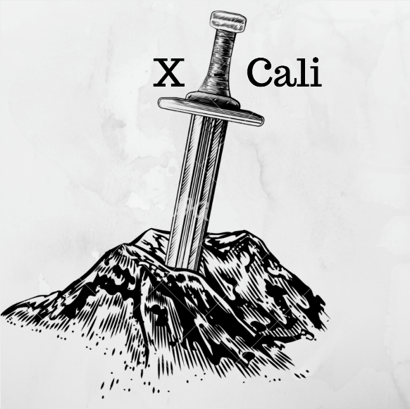

**Critical Design Review Report**

*“Design of Robots Collaboratively Carrying a Long Object Through an Open-Top Maze”*

Submitted to: Ali Özgür Yılmaz

Date of Submission: March 9, 2018

**Company Shareholders**

* Oytun Akpulat 2093201 [oytun.akpulat@metu.edu.tr](mailto:oytun.akpulat@metu.edu.tr)
* Göksenin Hande Bayazıt 2093441 [hande.bayazit@metu.edu.tr](mailto:hande.bayazit@metu.edu.tr)
* Emre Doğan 2093656 [dogan.emre@metu.edu.tr](mailto:dogan.emre@metu.edu.tr)
* Taha Doğan 2093672 [taha.dogan@metu.edu.tr](mailto:taha.dogan@metu.edu.tr)
* Burak Sezgin 2094456 [burak.sezgin@metu.edu.tr](mailto:burak.sezgin@metu.edu.tr)

Contents

Introduction 3

Project Goals and Objectives 3

Problem Definition 3

Objectives 5

Company Objectives 5

Project Objectives 5

Design Description 5

System Description 5

Subsystem Analysis 9

Body 9

Detection 10

Movement 18

Component Analysis 18

Microcontrollers 18

Main Computer 19

Sensors 20

Motors with Encoder 20

Motor Driver (H-Bridge) 20

Battery 21

Chassis and Mad Wheel 22

Requirement Analysis 22

Risk Analysis 24

Mechanical Risks 24

Safety Risks 24

Customer Risks 24

Power Consumption Analysis 24

Cost Analysis 24

Development Schedule 26

Modification to Conceptual Design 33

Test Procedures and Test Results 34

Deliverables 34

Organization Plan 35

Conclusion 36

References 36

# Introduction

This report describes the hardware and software progress and implementations carried out so far.

As the company X-Cali, we have completed most of the hardware implementation of the project. Physical architecture of the robot has been designed and almost finalized. We have also remarkably proceeded at the software part of the project. For subsystems, the design procedure was completed and final decisions were made. Even though we do not have a full functioning robot now, we made tests on subsystems and the results of these tests are included in this report.

Detailed description of the overall system and subsystems are given in this report. Technical details of designed systems were explained. Moreover, block diagrams, flow charts and 3D technical drawings of the subsystems are included. At the “Modifications to Conceptual Design” part, all the development and modifications to the system were clearly clarified. The cost and risk analyses of the robot are made. Finally, we mentioned our future plans in “Development Schedule”.

# Project Goals and Objectives

## Problem Definition

In this project, we aim design and produce a robot that can carry a long object, plank, through a maze collaboratively with another robot. Maze specifications is as follows.

* There are 5 streets maximum on the one side of the maze
* Street are 250 mm wide
* Maze walls are with 100 mm height
* Maze walls’ width is 10mm
* 10 mm from the top of the maze walls are painted with black, the rest is white.

After robots are connected each other with the plank, one of them will be chosen as master and the other slave. Master leads the way in the maze and slave robot follows master. The main problem in this project is “Handling the corners”. That is, in the case of U-turn, robots are not able to handle it at once. The whole procedure in such a case is given in the Figure 1.

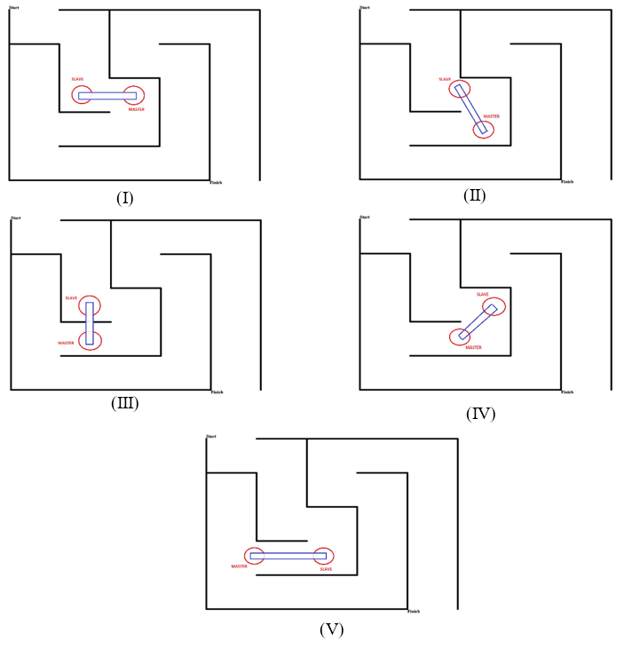

Figure 1: U-turn demonstration

Robots are not allowed to communicate each other directly. Thus, during the maze solving operation, our robot X-Cali performs *sensing*. Both active and passive sensing approaches are applied on X-Cali.

As X-Cali Group, our main aim is to design and produce a robot, is a solution for this maze problem, in in an efficient way. Efficiency is in terms of both software and hardware efficiency. Robustness is achieved firstly in the mechanical design period and it is improved with software. We have chosen the colors in a way that image processing is affected less by changing environment conditions such as light, brightness or shadows. Additionally, we have taken to account aesthetic beauty as we bear commercial concerns. The robot is designed symmetrical manner so that its posture increases its sales appeal. Because of the commercial concerns, after sale services are also provided for this design.

## Objectives

### Company Objectives

* Improving theoretical and practical experiences
* Applying theory on practice
* Continuing in grow and being a corporate
* Overcoming the project
* Increasing the team skills: productivity and efficiency and time management
* Placing first in the contest at the very end of semester

### Project Objectives

* Minimalist and efficient design
* Considerably low power consumption
* Completing the maze without collision and damaging the other robot
* Keeping customer satisfaction high by providing high quality after sales services

# Design Description

## System Description

This project aims to build a robot that can collaboratively carry an object with another robot in an open-top maze. This duty’s main requirements are designing a robot which is aware of its surrounding and which can freely, predictably and precisely move. To achieve this purpose, we have designed and built the robot in three main subsystems according to their functions. The robot includes a body part, which is the main chassis and passive components on it, a detection part that is composed of a camera, proximity sensors and algorithms that provides surrounding awareness, and finally movement part with motor drive system, tires and movement control algorithms. These subsystems are discussed and explained in detail further in the report. Also, detailed block diagrams, flowcharts of these subsystems, technical drawings and general appearance of the robot are provided on Figures 2 to 6 below.

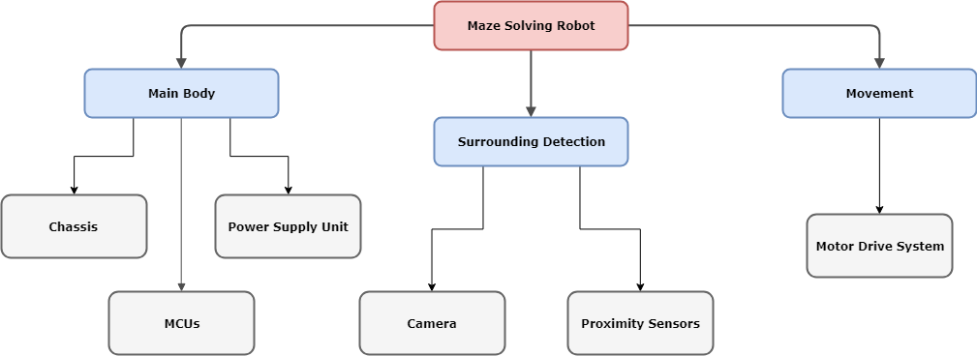

Figure 2: Block Diagram of the Overall System

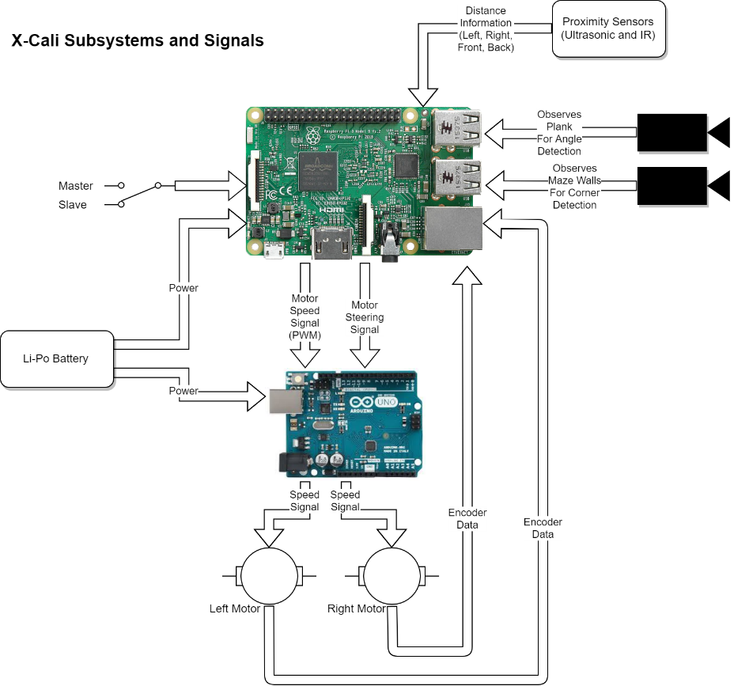

Figure 3: Flowchart of the System Functioning

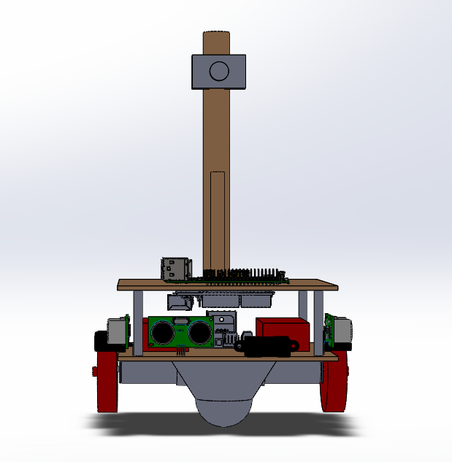Figure 4: Technical Drawing of the Robot (Front View)

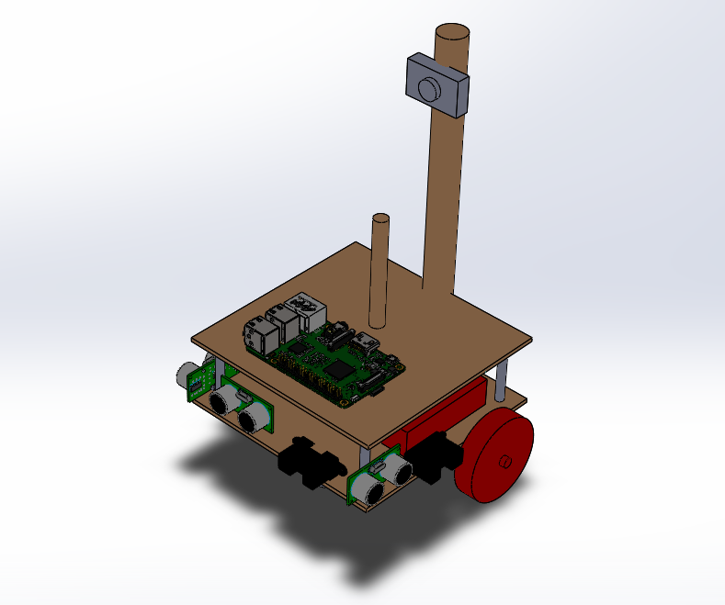

Figure 5: Technical Drawing of the Robot (Isometric View)

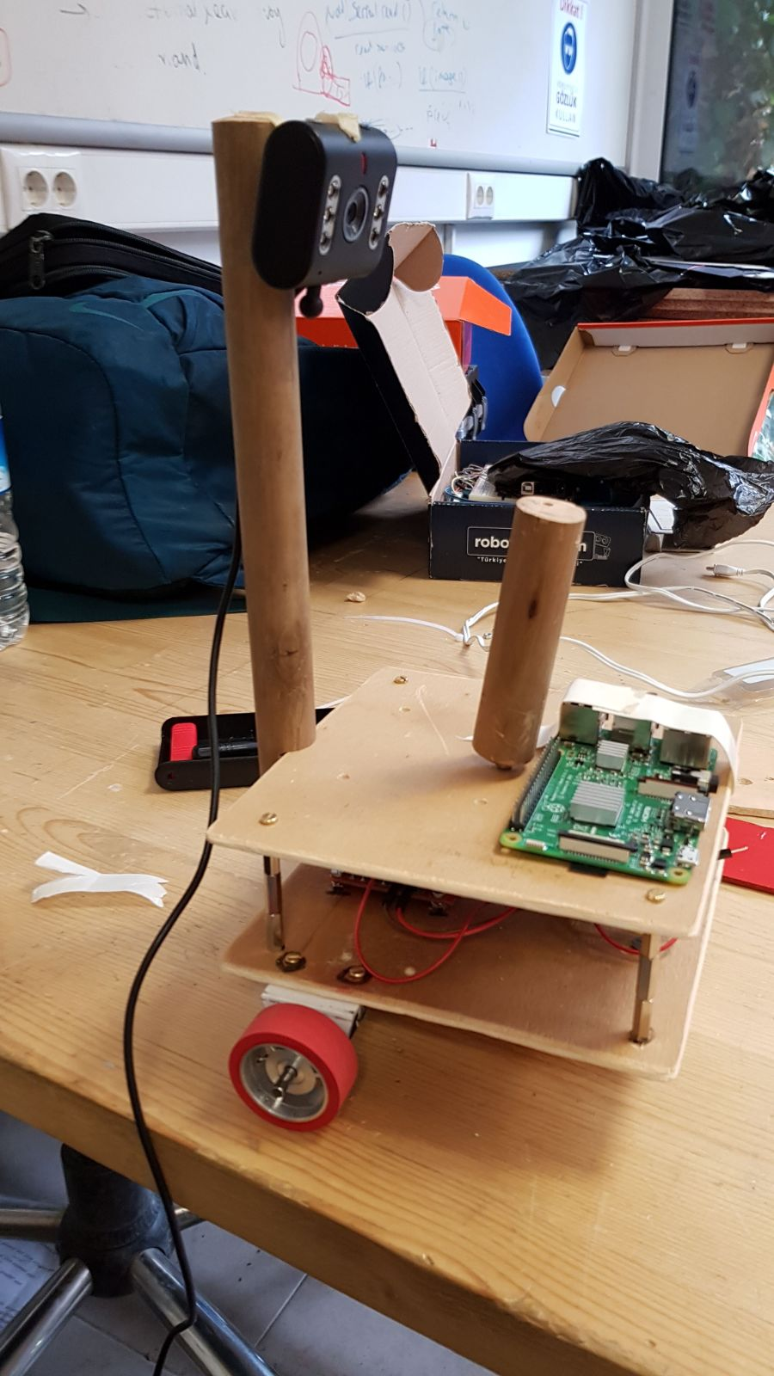

Figure 6: General Appearance of the Robot

## Subsystem Analysis

### Body

#### Chassis

The main platform of the robot is manufactured using hardboard considering its lower weight, durability, strength and convenience for mechanical assembly processes. As displayed in Figure (Teknik çizim) above, the robot is composed of two staged hardboard platforms that are 150 mm both in width and in depth. These stages are separated with metal supports that are 45 mm long. It was important for the footprint of the robot to be small because of restrictive standards and high maneuverability.

Two sticks are mounted on the chassis, for the plank and as a camera holder. These sticks are also made of wood, because of its lower weight and strength. Top of the holder stick of the plank is 170 mm above the ground, as determined in Standards Committee. On the holding point, a ball bearing is placed in order to reduce the friction of the plank while rotating. Camera holder is placed behind the plank holder and it is higher than it for a better perspective.

Heavier components are placed on the platform at the bottom, to decrease the level of center of gravity. Another consideration while placing the components is placing electronic parts that are in connection close to each other, to avoid complexity caused by cables and provide easy debugging.

Most of the passive components and motors are mounted on the platforms with screws and nuts to eliminate negative effects of mechanical vibrations on the system. Also, plastic clamps are used where necessary.

#### Power Supply Unit

The robot has two LiPo batteries that are 11.1 V and 1300 mAh. One of these batteries is to supply power to MCUs and the other supplies power to motor drive system. The main reason for using separate batteries is protection of sensitive electronic components from a damaged caused by high current. Also, at startup, motors draw high current, which causes a voltage drop on the other equipments that are connected to same battery. This issue causes a continuous “resetting” problem of MCUs. Batteries are placed on the bottom platform of the robot, as they are heavier components and it is necessary that they are close to the components that are going to be connected to them.

#### MCUs

The robot includes a Raspberry Pi 3 and an Arduino Uno. Arduino Uno is mainly used for motor driving and controlling purposes, whereas functions such as image processing, decision making are performed using Pi.

### Detection

In the robot, there are mainly 3 subsystems to have a knowledge of the surrounding of the robot. This subsystem supplies the most important data for the decision unit. All decisions will be made with respect to the signals taken from

* Camera
* IR Sensors
* Ultrasound Sensors.

These awareness sensors help the robot find its path in the maze and lead or follow the other robot. The structure of this module is given in Figure 7.

Figure 7. Block Diagram of the Surrounding Awareness Submodule

#### Angle Detection

In the plank angle detection, the image capture is taken from the camera and processed simultaneously. The main purpose is to achieve the angle of the plank to be able to identify the other robot’s moves. With interpreting this angle in the critical points of the maze, the robot will be able to find its correct move in the decision unit.

For this, we firstly developed an algorithm to be able to detect the correct angle. As the camera within the robot will see the plank in an uneven pattern, this image needs to be fixed so that we could find the angle in a more reliable way. The procedure is given below,

1. The colorful image is taken as an input
2. The input image is masked as processing in the grayscale is much more practical.
3. The uneven masked is image is applied some transforms to get a more linear shape.
4. Angle finding algorithm is applied to the transformed image.

An example of this process can be observed in Figure 8.

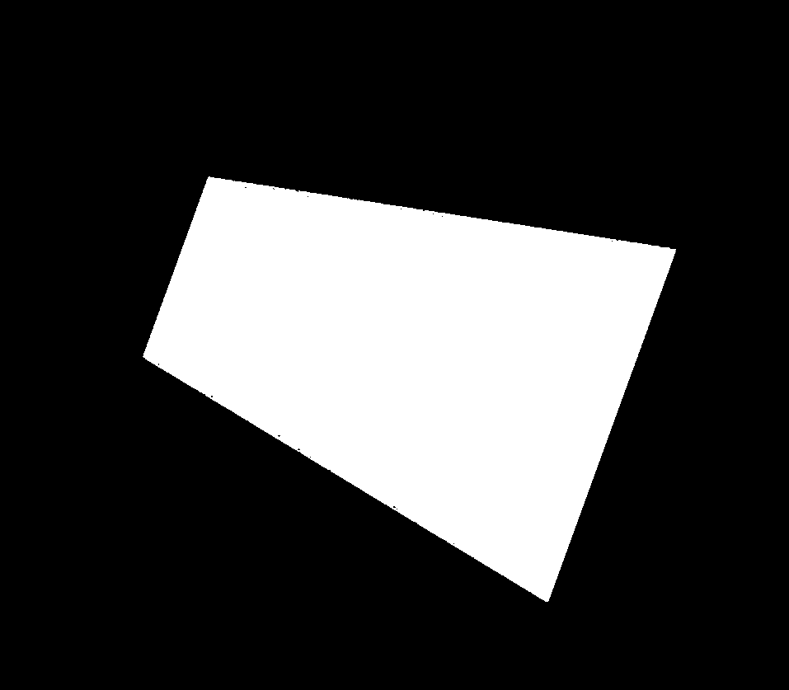

1. (b)

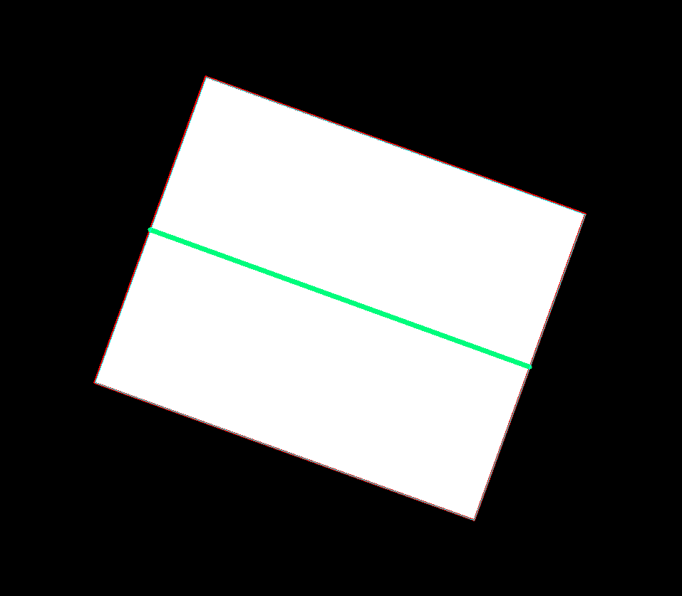

(c) (d)

*Figure 8. The original input image (a), the masked version of the input image (b), the transformed version the input image, not uneven (c), angle detecting algorithm applied to the transformed image (d).*

After the angle of the plank is detected, this information is sent to the decision unit so that the decision unit sends the necessary signals to the motor driver.

An illustration of this process can be seen in the command prompt in Figure 9.

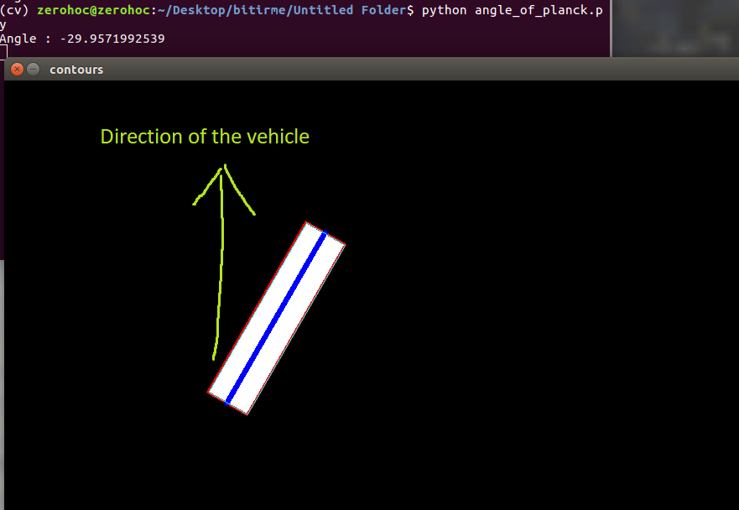

Figure 9 Angle Detection Output of the Plank.

All this algorithm process was debugged and developed on the computers. Then, we made a demonstration on the real robot, to see whether it could find the angle of the plank in a correct manner. Figure 10 given below is a basic demonstration of the algorithm on the Raspberry Pi 3, while all the robot components are integrated.

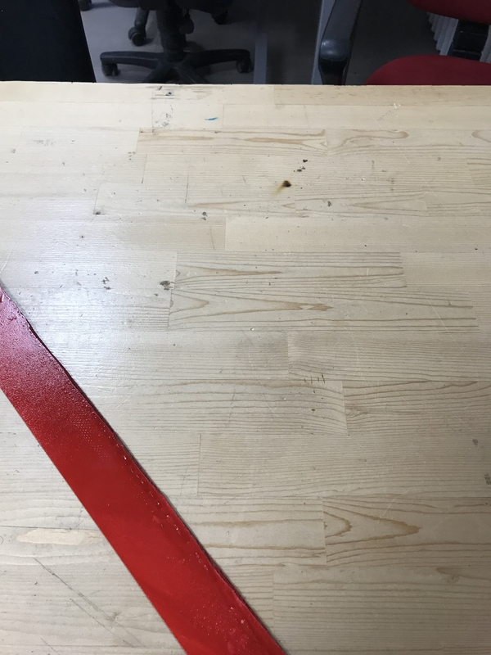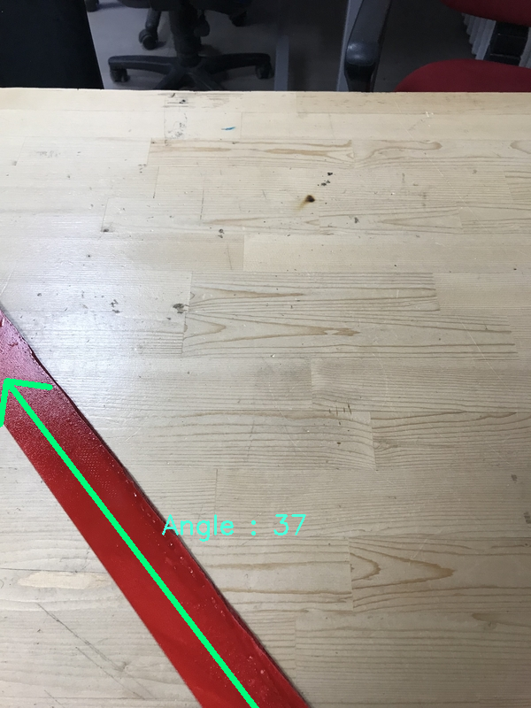

1. (b)

Figure 10. Demonstration of the Angle Detection Algorithm on the Robot.

The camera captures the plank from the top view(a), then the angle detection algorithm is applied to find the angle(b).

#### Maze Mapping

Besides the angle detection of the plank, we also use the camera to map the maze from the top view. Maze mapping is important because it eases to decide what the robot should do as its next move. For this mission, the camera used in the angle detection cannot be used as the perspectives are quite different. So, we will use another webcam camera to map the maze located higher than the angle detecting camera.

Especially in the U and L turns, mapping the maze is important because the robot will remember its last moves and complete the turn with respect to this fact.

In our first try, we tried to map the maze visually such that while the robot is moving, the camera at the top will be observing the maze and from the edges of walls, it will create a map of the maze. A visual illustration of this mapping is given in Figure 11.

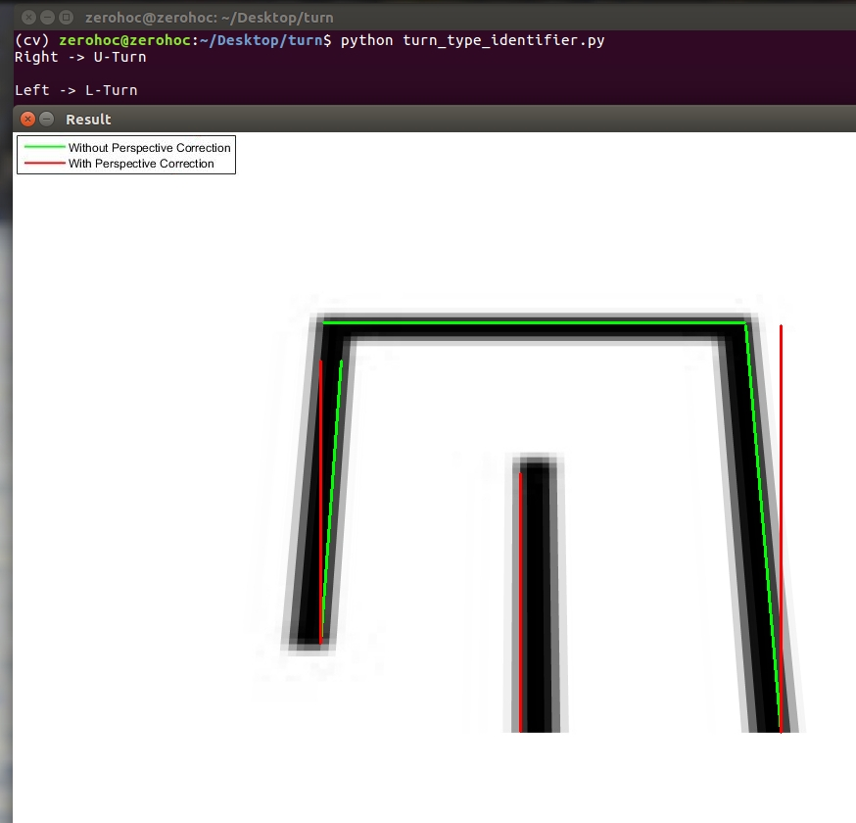

Figure 11. Maze Mapping Algorithm Visualization.

After mapping the path, this information is used to save a few movements which the robot completed. This becomes an important issue especially when there is a L or U turn. In the Figure 11, it is also available to observe these movement detections made.

This method is useful but it has some disadvantages. Mainly, this process is comutationally complex and it reduces the performance of other processes done in Raspberry Pi 3. So in stead of this, we thought about a new method of mapping which is less complex in computation.

In this method, a sufficient sized of matrix is created. As the robot goes through a path, this matrix is filled with “1”s to represent the path in the matrix. This method may seem strange but as it consumes much less CPU, it is preferrable rather than the visualization method mentioned above. An example of mapping array can be seen in Figure 12.

$$path_matrix=\begin{matrix}0 & 0 & 0 & 0 & 0 \\ 0 & 0 & 1 & 1 & 1 \\ 1 & 1 & 1 & 0 & 0 \\ 0 & 0 & 0 & 0 & 0 \\ 0 & 0 & 0 & 0 & 0\end{matrix}$$

Figure 12. An Example of Mapping Matrix.

Path matrix is a 5x5 matrix initialized with all 0s. The robot begins its path from $path_matrix[3,1]$ point. Then it follows the $path_matrix[3,2]$, $path_matrix[3,3]$, $path_matrix[2,3]$, $path_matrix[2,4]$, $path_matrix[2,5]$. This visualization type is not strong but lets us to save the last few moves the robot made without occupying the processor.

#### Finding the Path Through the Maze

Besides the plank’s angle detection and maze mapping, the robot should be aware of its surrounding while moving. For this subsystem, we have 2 options,

* Infrared (IR) Sensor
* Ultrasonic Sensor

IR and ultrasound sensors give information about the obstacles around the robot. This is quite important for the robot to be able to drive itself through the maze platform without hitting walls.

Both of them have their advantages explicitly.

*Advantages of Ultrasonic Sensors Over IR Sensors*

* They are completely insensitive to environmental factors like,
* Light
* Dust
* Vapor
* Mist

So, this sensor type makes the system more independent to the environmental factors which is good.

*Advantages of Infrared Sensors Over Ultrasonic Sensors*

* They perform better at defining edges of an area. As our robot needs to define the walls of maze and the other robot, using IR sensor might have a positive impact on the distance measurement performance.

For this performance difference, IR Sensor is more preferable rather than the ultrasonic sensor.

In our robot, we will keep both types of sensors. We still have doubts on the trade-offs between them. Most probably, one of them will not be needed. But, just in case we will be keeping both of them on the robot.

### Movement

The robot has rear wheel drive system. Motion is achieved with two tyres connected to the shaft of two DC motors at the back of the robot and a mad wheel at the front middle of the robot. Mad wheel provides mechanical stability to the system and increases the maneuverability.

In the second iteration of the robot, motors are replaced with DC motors with gearbox and encoders. Encoders are used to obtain instantaneous speed data from the motors, which is necessary for motor control.

Motor control is achieved with an Arduino and using PID control. Control algorithm is designed such that KP, KI and KD parameters are determined using the data retrieved from proximity sensors and instantaneous speed data read by motor encoders.

## Component Analysis

One of the most important and critical step in progress of development of the project is component selection. We made necessary researches and with respect to the results of these researches we chose the components of our robot. These selections are explained below.

### Microcontrollers

Our criterias while choosing the microcontroller was speed, low price and compatibility. After some research, we concluded that Arduino Uno, Figure 13, is the best option for us since it is cheap, fast and compatible.

It has 28 pins including 16 digital pin, 6 analog pin, 5 power pin and a reset pin. These are enough for our needs.

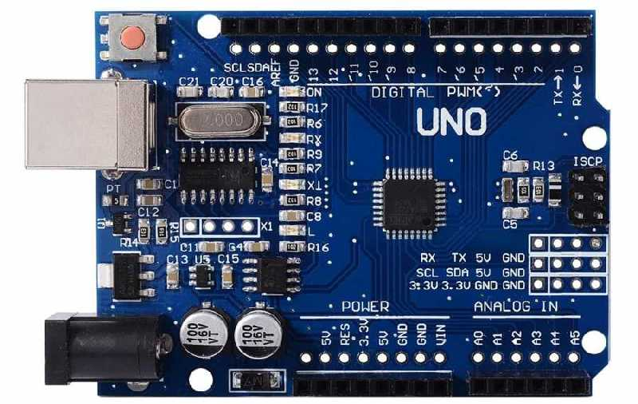

Figure 13: Arduino Uno

### Main Computer

We needed to choose mini computer that has the highest performance/price ratio. We also had to consider our budget and choose the computer accordingly. Raspberry Pi 3 was chosen.

Raspberry Pi 3, Figure 14, has HDMI, USB 2.0 and Ethernet connections, Camera Serial Interface, Display Serial Interface and 40 general purpose input/output pins.

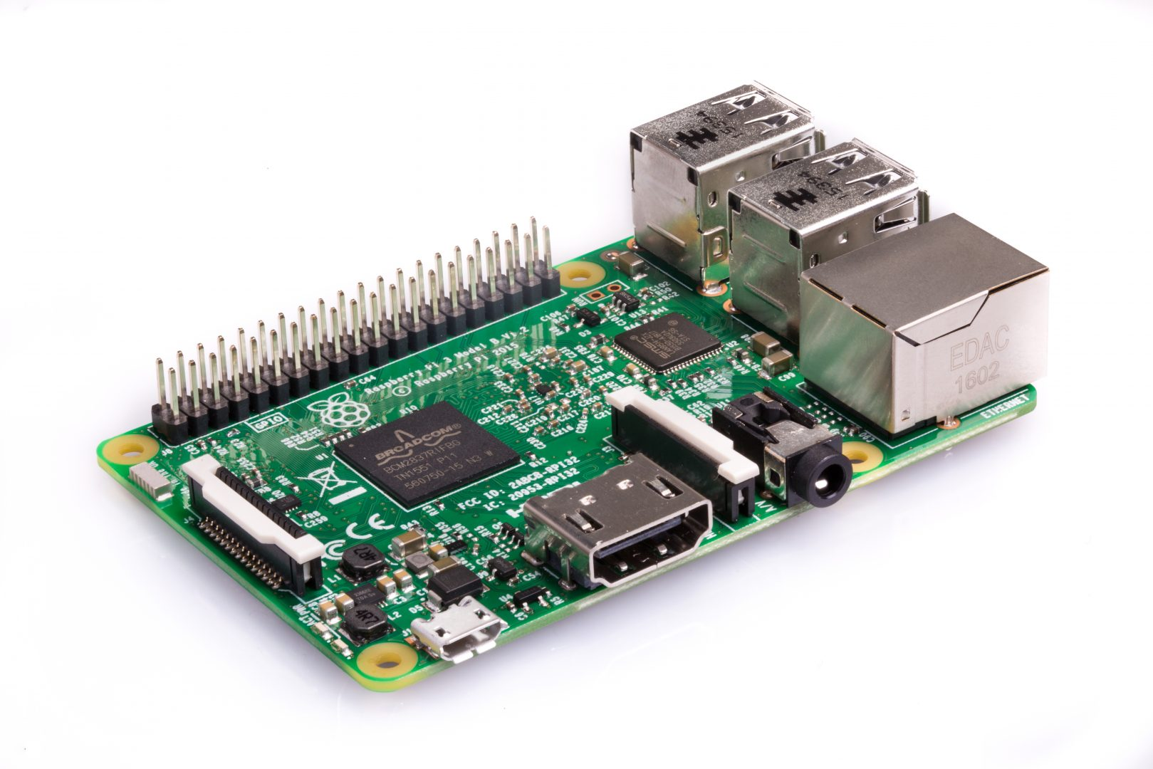

Figure 14: Raspberry Pi 3

### Sensors

#### Ultrasonic Sensor

We used ultrasonic sensor in order to measure the distance. HC-SR04, Figure 15, was chosen for this purpose.

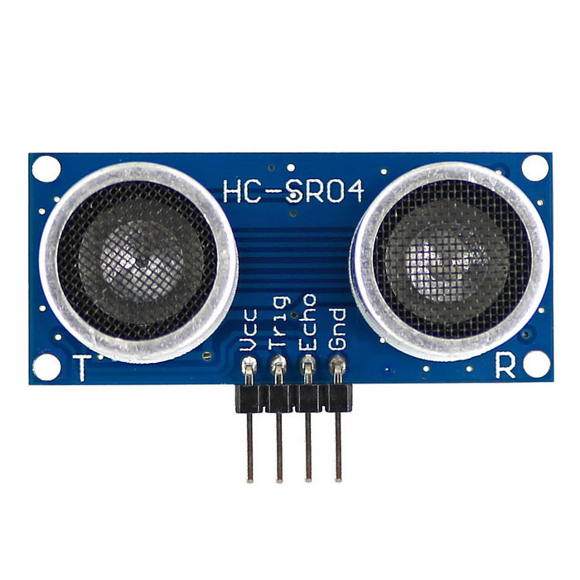

Figure 15: Ultrasonic Sensor HC-SR04

#### IR Sensor

IR sensor is also used for distance measurement.

### Motors with Encoder

We selected a powerful enough motor with encoders. The data coming from the encoders will be processed in Arduino. Encoder data is important since it provides the robot with direction information.



Figure 15: The motor

### Motor Driver (H-Bridge)

Our priority was to select an H-Bridge that is cheap and compatible with the other parts of the robot. We chose L298N H-Bridge since it satisfy our requirements.

Two DC motor can be controlled with L298N, Figure 16, in both directions. It provides 2 A current in maximum case.

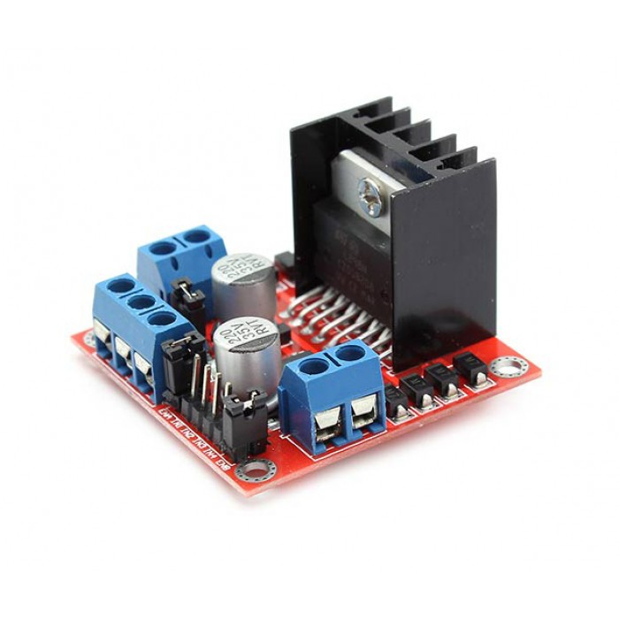

Figure 16: L298N H-Bridge

### Battery

We needed to select a battery that is cheap, compatible with the other parts of robot, easy to use and easy to find information. We decided that the best choice is Li-Po battery.

#### Camera

Camera selection was one of the most critical parts of the project since our main solution relies on camera. After some research, we considered the performance/price ratios and decided to select a Bewell camera, Figure 17. It is a cheap camera, we can change it with a better one if our budget lets us.

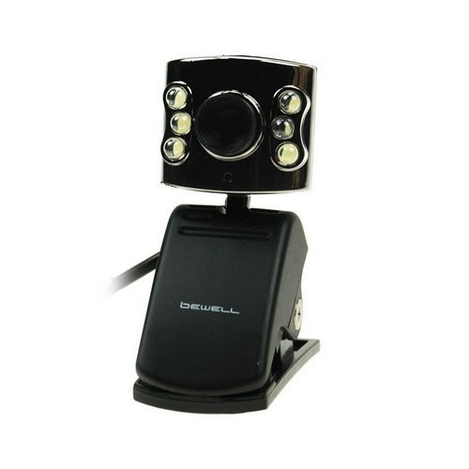

Figure 17: Bewell Camera

### Chassis and Mad Wheel

We selected a wooden chassis which forms main body of the robot. It has several holes for motor connections, sensors, circuit cards and other components. Mad wheel is chosen as third wheel since it provides the robot with maneuverability.

## Requirement Analysis

All the requirements decided in the standard committee are evaluated in the Table 1.

**Table 1 :Requirement Analysis of the Project**

|  |  |  |
| --- | --- | --- |
| # OF STANDARD | PROJECT STANDARDS | STATUS |
| 1 | Color of the ground and walls should be white. | Designed, but not implemented. |
| 2 | Height of walls should be100 mm. | Designed, but not implemented. |
| 3 | Upper side of walls (between 90mm height – 100mm height) should be black. | Designed, but not implemented. |
| 4 | Top of every wall pieces should have 1 cm width and should be black. | Designed, but not implemented. |
| 5 | Plank should have 3 mm thickness, 50 mm width and 500 mm length. | Designed and implemented. |
| 6 | Color of the plank should be red and material of plank should be hardboard. | Designed and implemented. |
| 7 | Shape of the holding point should be circle. Diameter of this circle should be10mm. Length between centers of the holes is 400 mm. | Designed and implemented. |
| 8 | Robots of companies should fit into a square. This square has a 23cm side length. | Designed and implemented.  Our robot fits into a square of 15 cm side length. |
| 9 | Height of the holding point should be 17cm. | Designed and adjusted. |
| 11 | The maze should be modular and reconfigurable. In other words, walls can be removed or added on the platform. | Designed, but not implemented. |
| 12 | Every team should design their own robot, maze and plank | Applied. |
| 13 | Every robot should be able to operate in each other’s maze and each other’s plank. | Not tried yet. |
| 14 | If the state changes, robots should behave accordingly. | Implemented in the software |
| 15 | Robots should move respect to right wall. | Satisfied. The algorithm is designed with respect to this fact. |
| 16 | The total cost of the project must be less than 200 USD. | Satisfied. |

As it can be observed from Table 1, the standards related to the robot and the plank has all been considered and applied. The ones related to the maze were considered in our maze designing process but as we have not implemented it yet, it was not possible for us to observe them physically.

## Risk Analysis

### Mechanical Risks

* The chassis of the robot is wooden. Wooden materials may lose their stiffness as time passes. Thus, it can be fragile over time.
* If robot is treated harshly, the camera holder and plank holder may be broken from the chassis.

### Safety Risks

* Li-Po Batteries in the robot may explode or start a fire or release poisonous gases during usage of the robot.
* Li-Po batteries may explode or start a fire or release poisonous gases during charging them.
* Overheating of microcontrollers may cause burns on the skin.

### Customer Risks

* Two more companies are preparing to enter this business with the same aspects and goals. This may cause decrease in the customer or failure in the sales target.

## Power Consumption Analysis

## Cost Analysis

After a detailed research process, we checked the market in order to be able to figure out how to solve the problem with the minimized cost. By making a comparison list, we found our optimal component set and purchased them. This component list can be observed below in Table 2.

**Table 2: Cost Analysis of the Project**

|  |  |  |  |
| --- | --- | --- | --- |
| **Product Name** | **Price / Product** | **Quantity** | **Total Price** |
| Raspberry Pi 3 | ₺181.65 | 1 | ₺181.65 |
| HC-SR04 Arduino Ultrasonic Distance Sensor | ₺5.50 | 4 | ₺22.00 |
| E18 D80NK Infrared Sensor | ₺22.75 | 2 | ₺45.50 |
| Webcam | ₺31.00 | 2 | ₺62.00 |
| Motors | ₺45.00 | 2 | ₺90.00 |
| L298N Motor Driver | ₺12.00 | 1 | ₺12.00 |
| Mad wheel | ₺5.00 | 1 | ₺5.00 |
| Robot Chassis | ₺10.00 | 1 | ₺10.00 |
| Jumper Cables | ₺10.00 (/set) | 1 | ₺10.00 |
| 11.1V 1300mA LIPO Battery | ₺69.50 | 1 | ₺69.50 |
| LIPO Battery Charger | ₺45.00 | 1 | ₺45.00 |
| 24V-5V 3A DC to DC USB Power Module | ₺6.65 | 1 | ₺6.65 |
| Arduino UNO | ₺40.00 | 1 | ₺40.00 |
| Screw set | ₺30.00 | 1 | ₺30.00 |
| Plank and ball bearings | ₺20.00 | 1 | ₺20.00 |
|  |  | **TOTAL PRICE** | ₺649.30 |

Please note that, we were allowed to spend up to $200,-. Total price is, according to today’s currency, $171.05. That is, we are far below the top limit.

## Development Schedule

As X-Cali, we were quite successful in our management plan despite the small breakdowns in our previous plan. Since we are halfway through and have little alterations in our plan, we saw fit to update our management plan and so our Gantt Chart. To start with, Communication Subsystem Design contents are updated to show the work to be done, more elaborately. Furthermore, Software Subsystem Design is divided into two branches as Raspberry Pi and Arduino, due to the addition of the Arduino. And their contents are updated to fit the branches, as well. Integration of Subsystems part was affected from this change and, Raspberry Pi and Arduino implementation processes is added. The rest of the management plans is kept as it used to be.

Aforementioned plans of X-Cali can be seen in Figures 18 – 23.

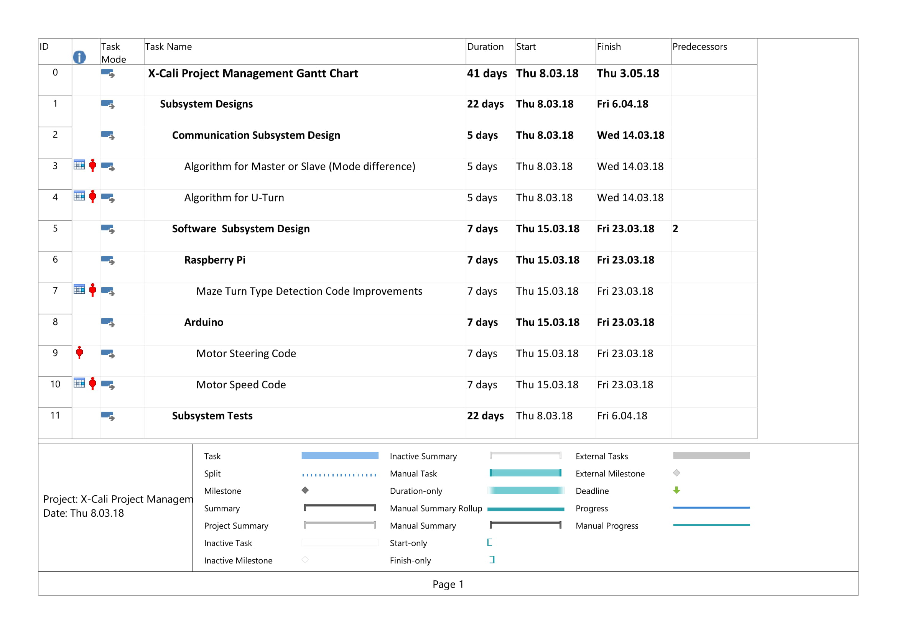

Figure 18. Gantt Chart (Management Plan) Page 1.

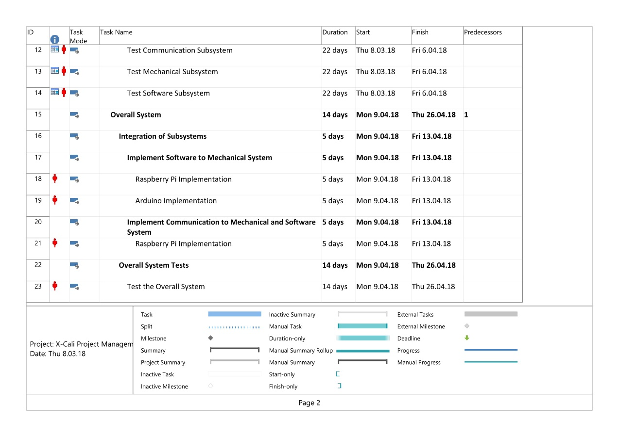

Figure 19. Gantt Chart (Management Plan) Page 2.

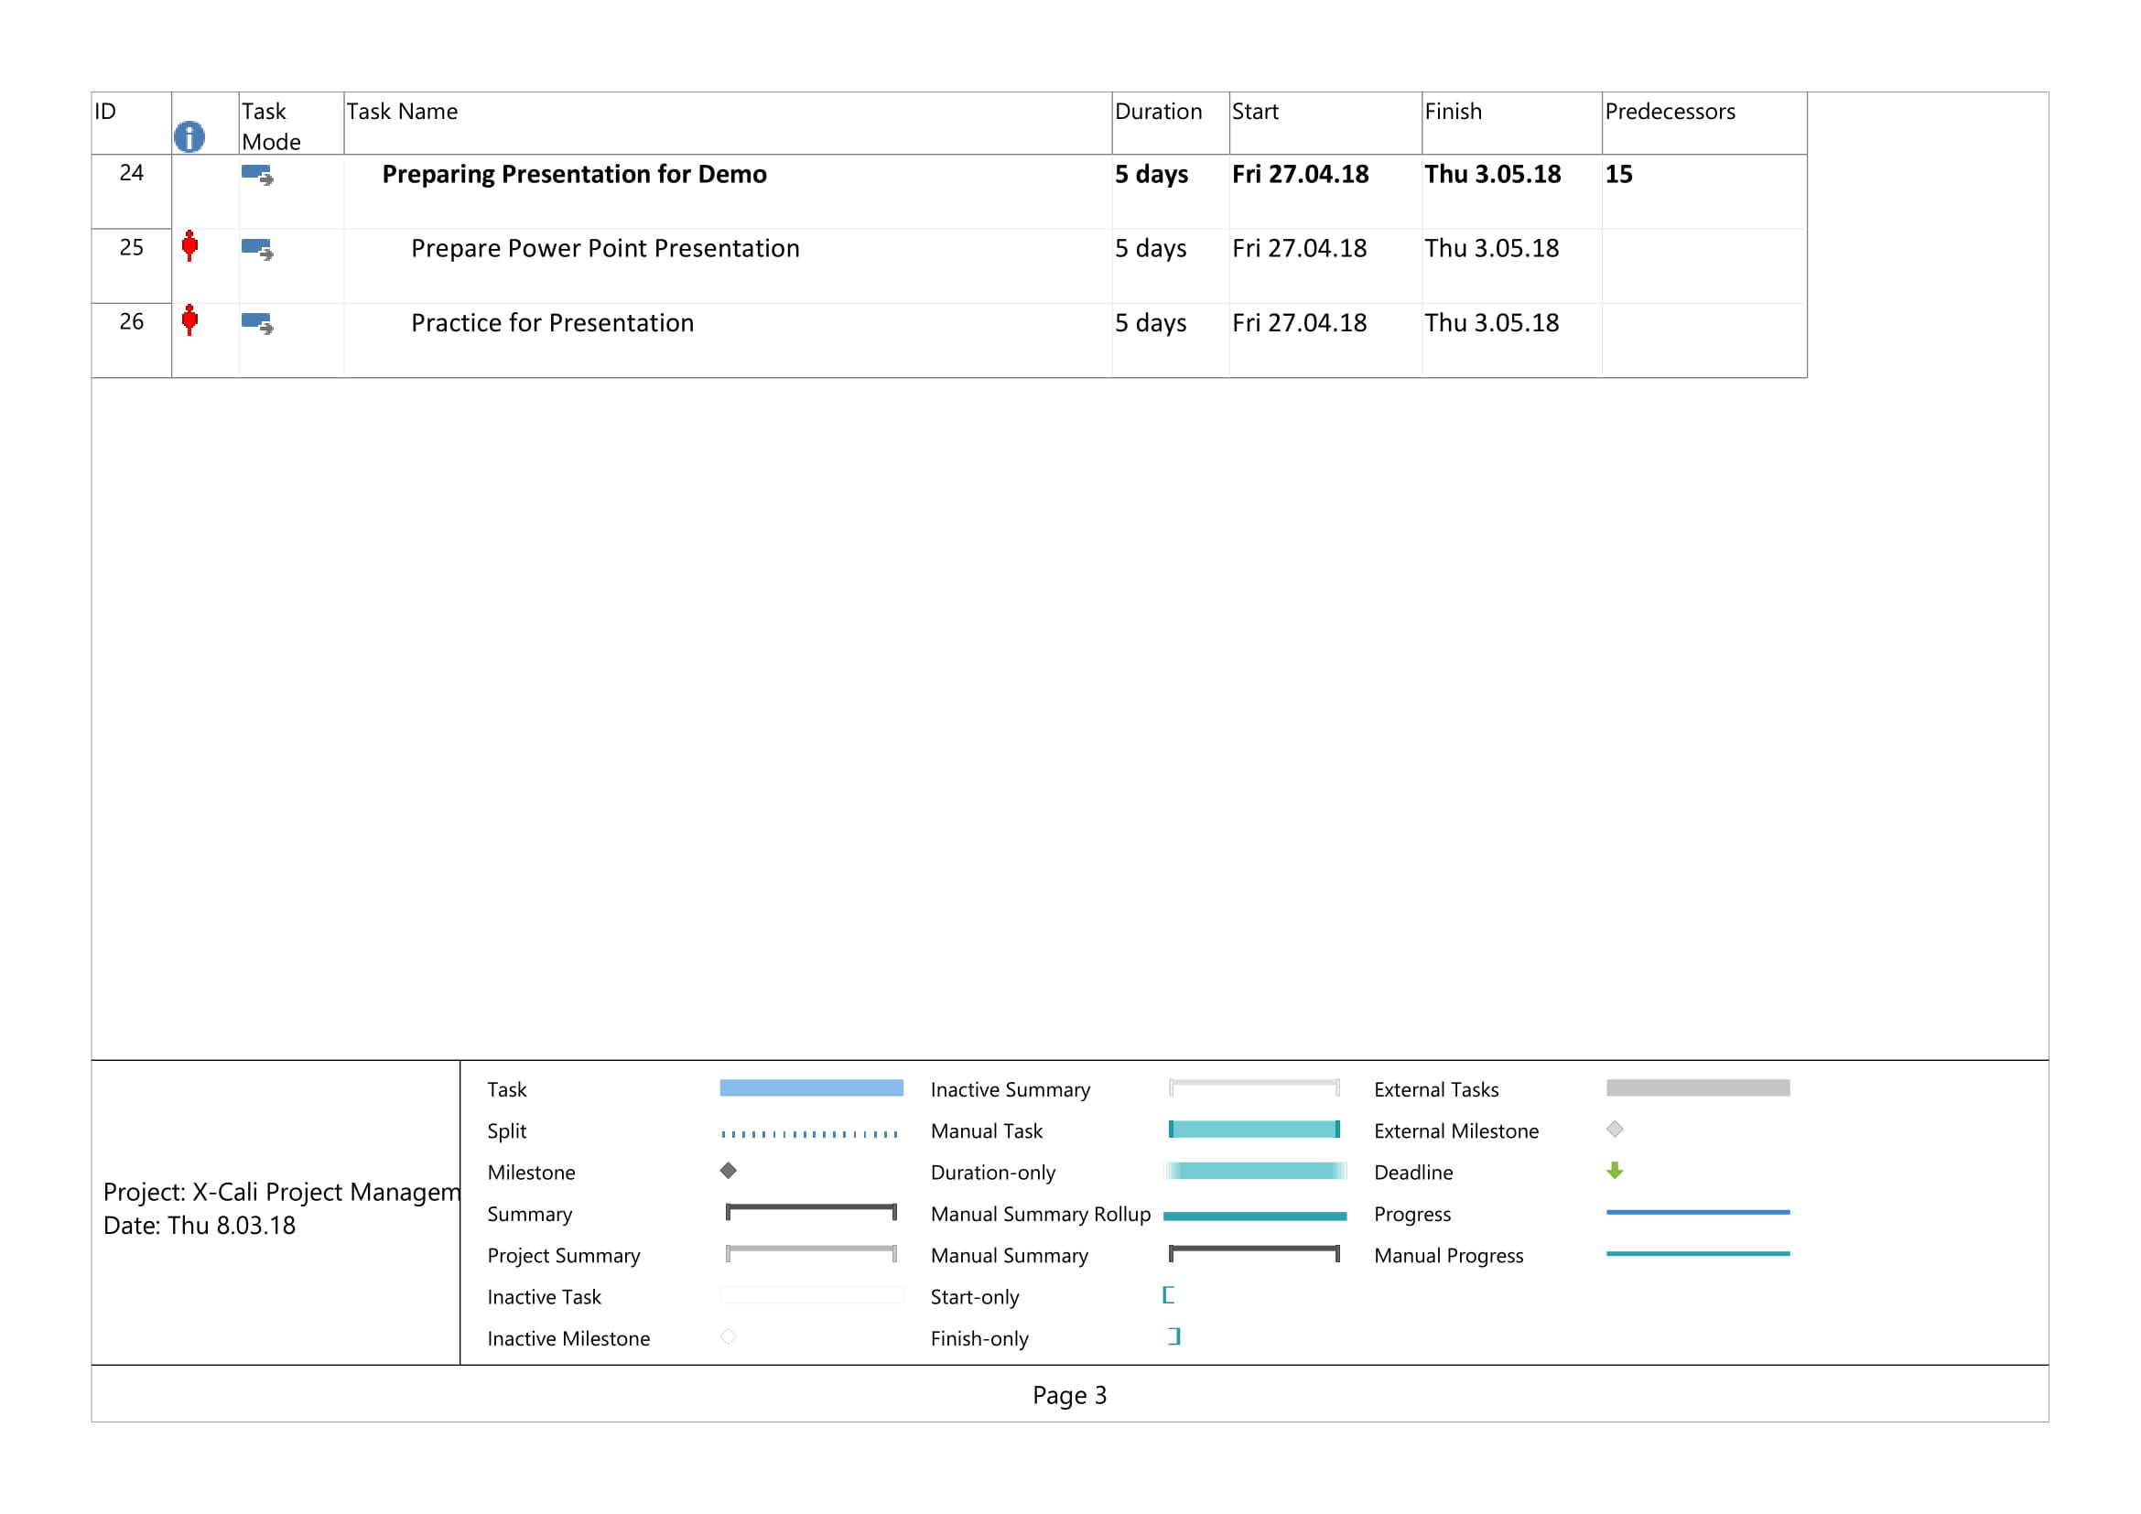

Figure 20. Gantt Chart (Management Plan) Page 3.

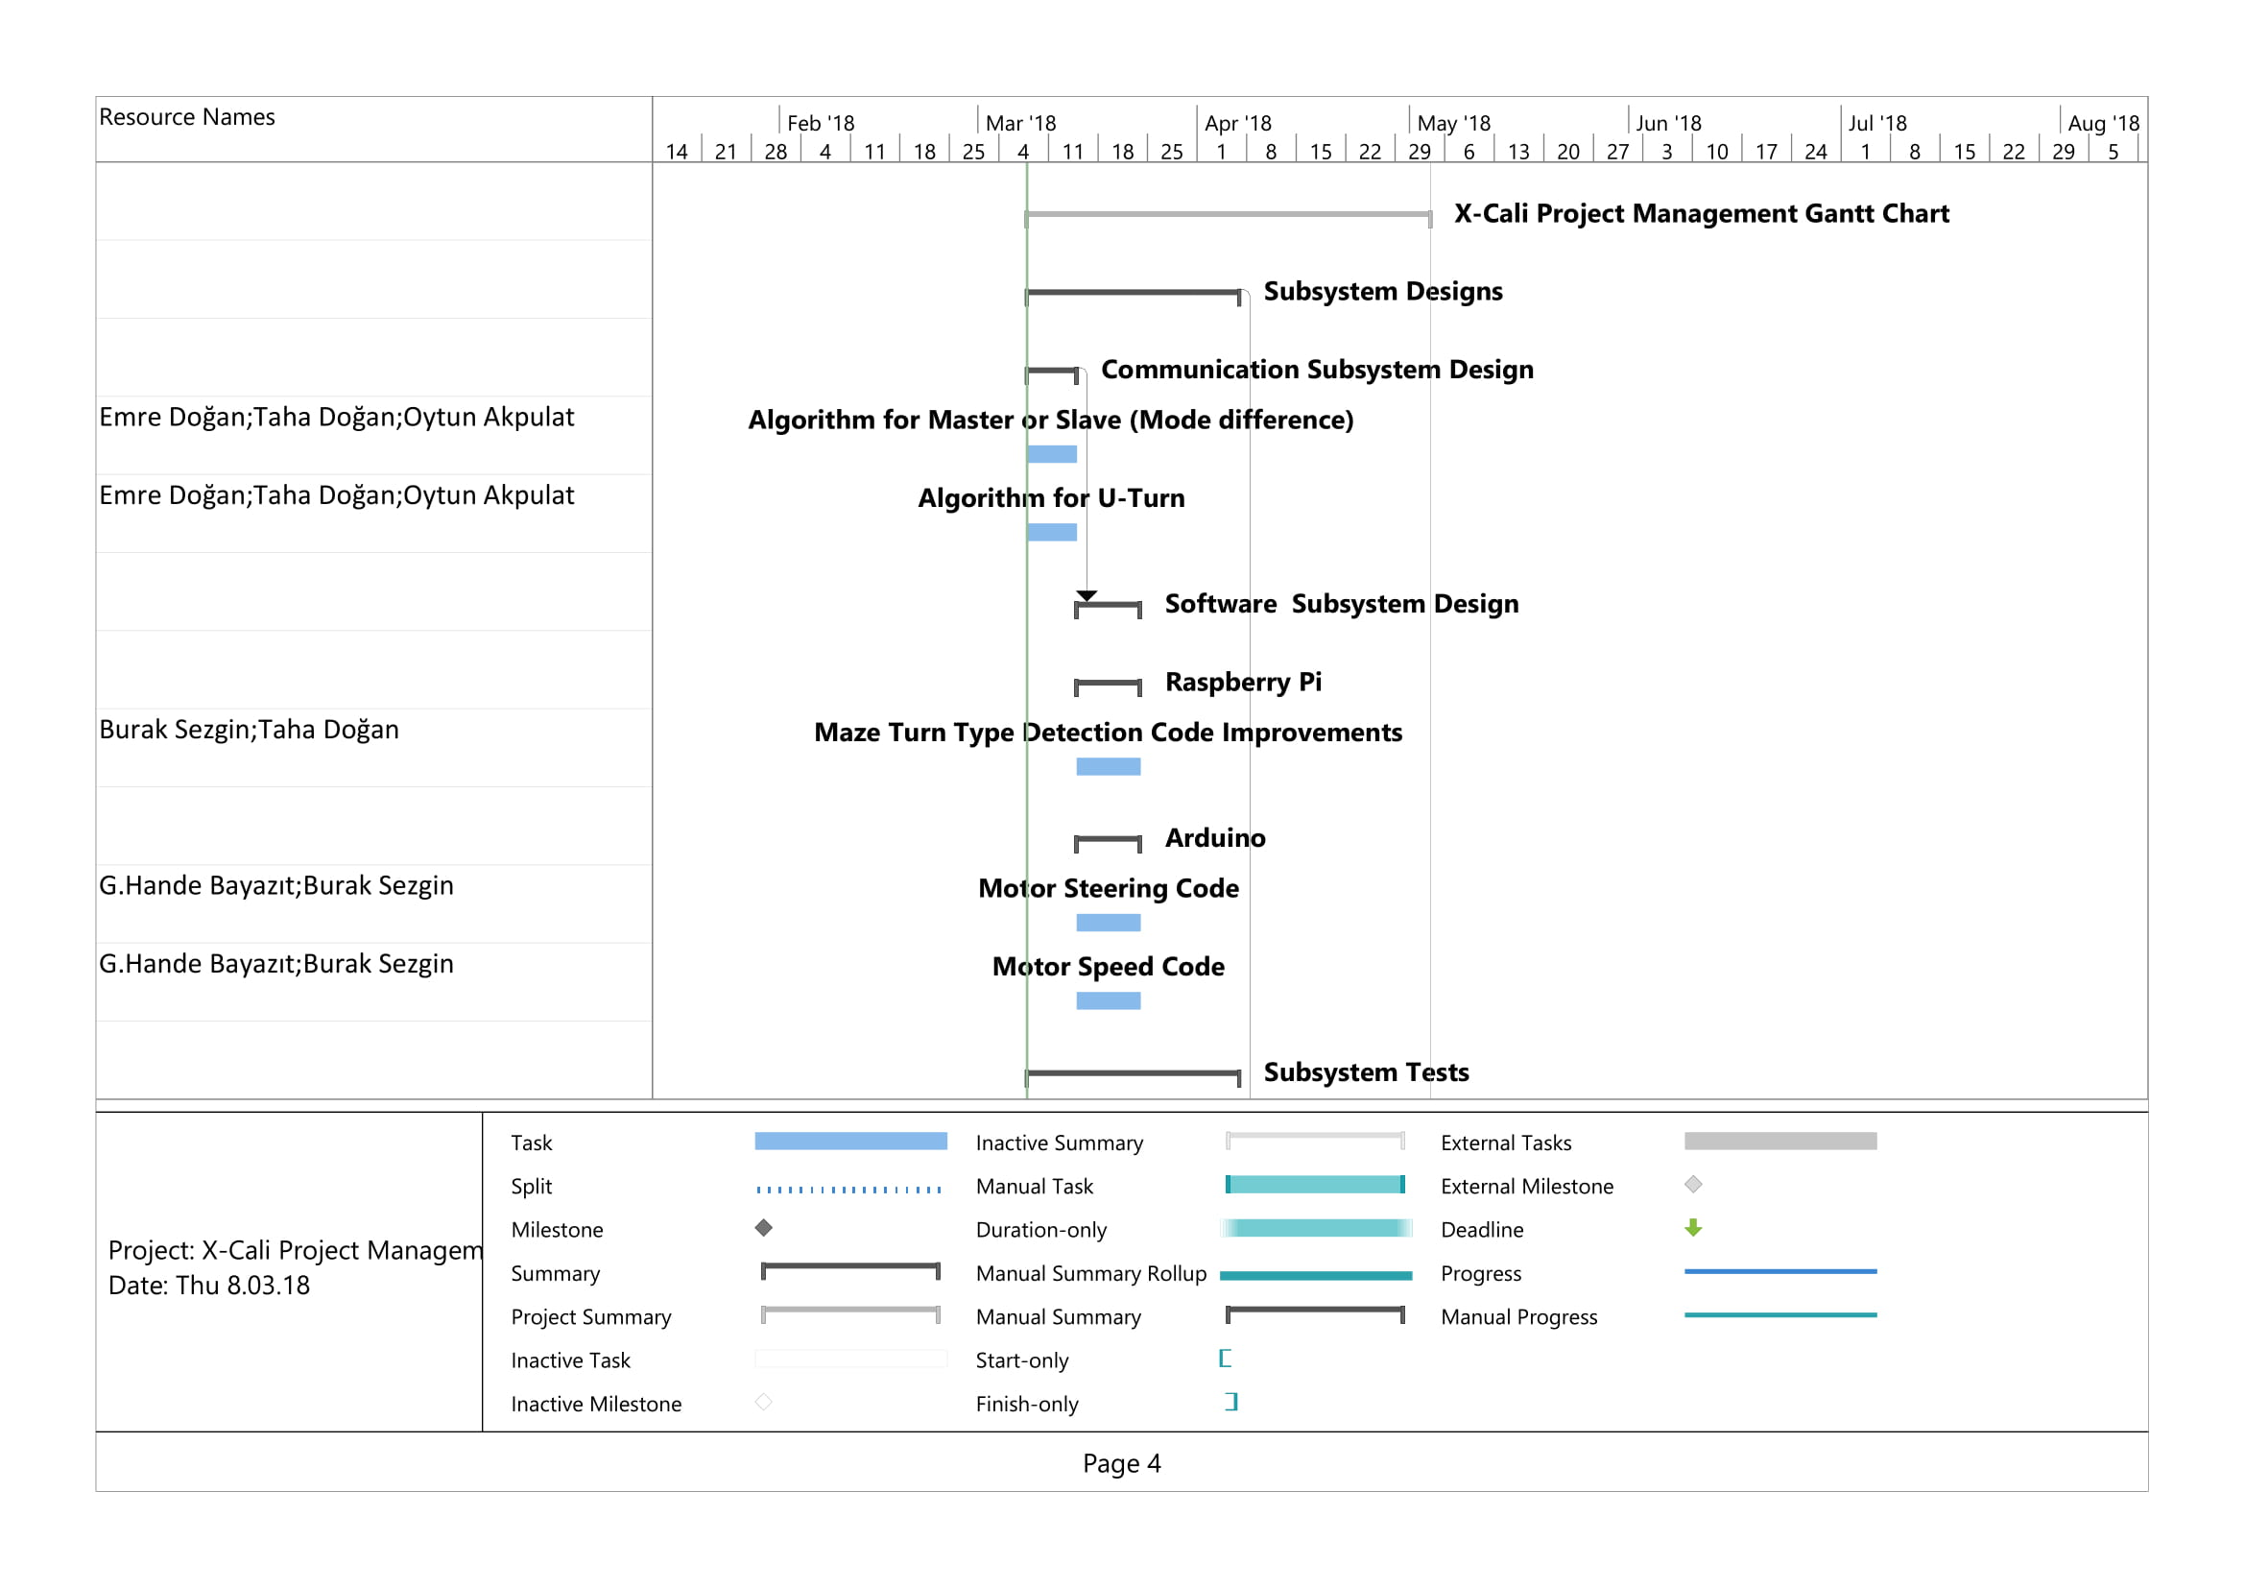

Figure 21. Gantt Chart (Management Plan) Page 4.

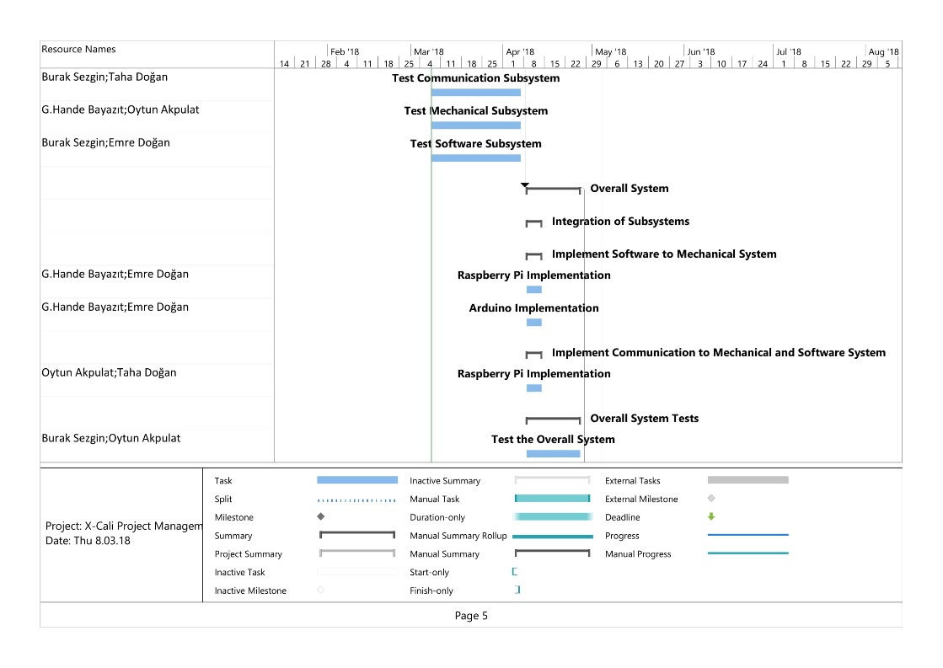

Figure 22. Gantt Chart (Management Plan) Page 5.

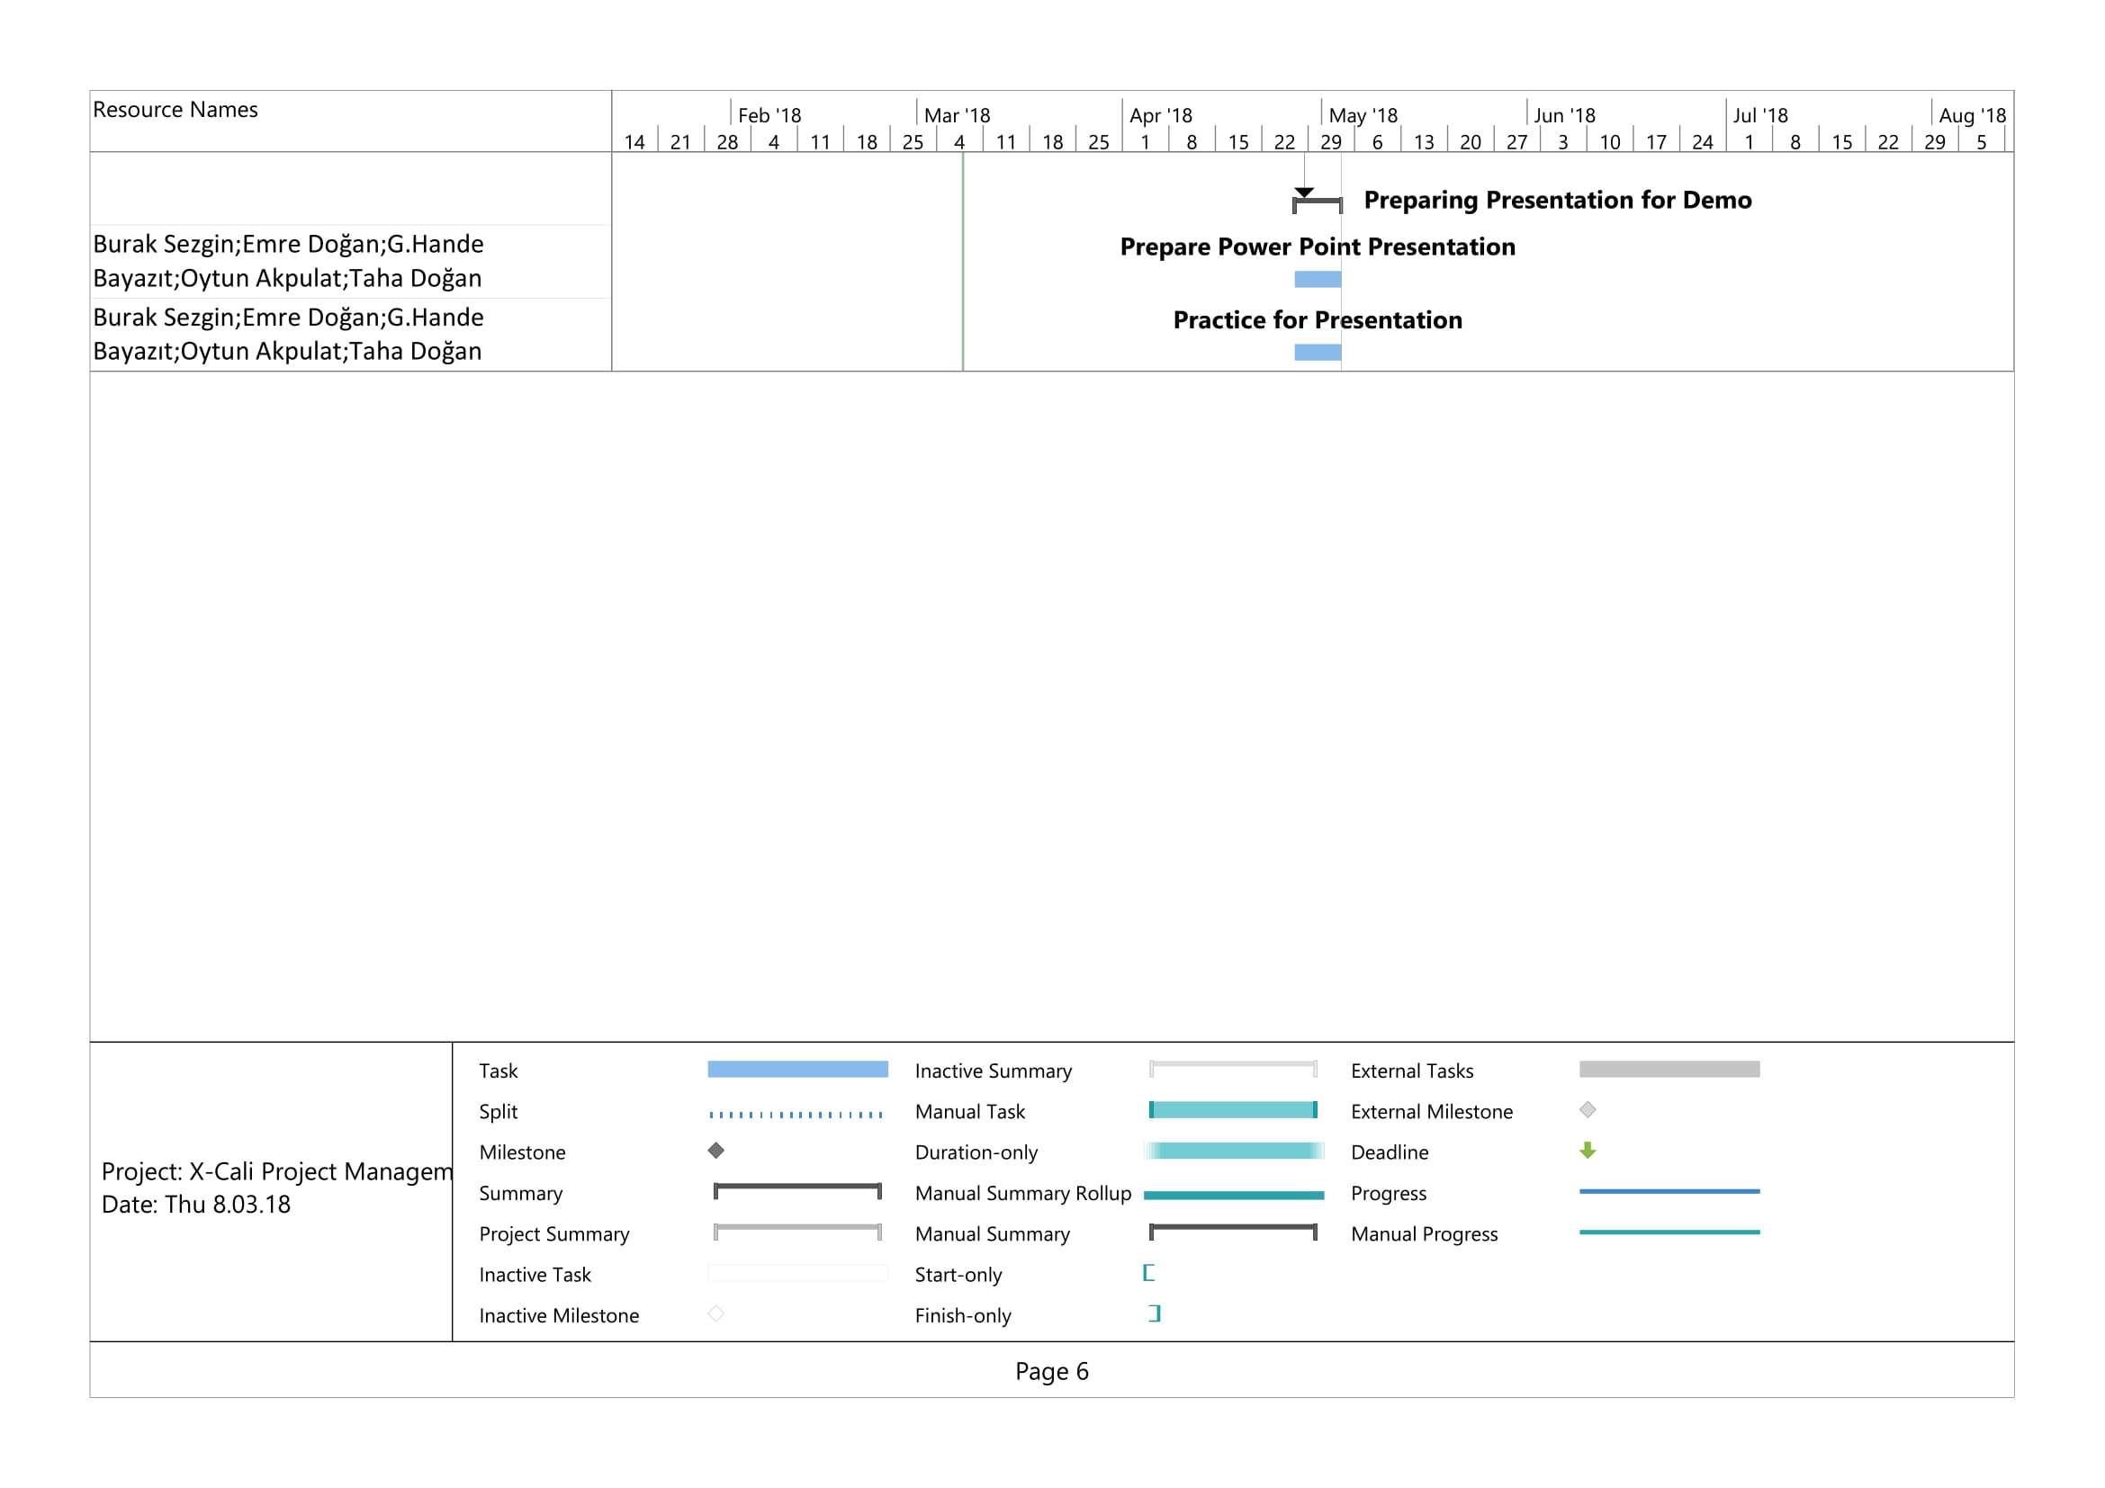

Figure 23. Gantt Chart (Management Plan) Page 6.

# Modification to Conceptual Design

In the Conceptual Design Report, different solution approaches and details of both software and hardware parts of the project were explained. After the report was submitted, we made some tests and evaluated advantages and disadvantages of the choices we made in hardware components. According to the results of this evaluation, we decided to modify some parts of the hardware of the project. These modifications are as follows:

* Arduino will be used for motor control since we already have a motor control code that works properly in Arduino.
* We decided to add an extra camera which means robot will have two cameras instead of a single camera. The reason for this is that both the movement of the plank and top of the maze could not be observed with a single camera.
* The motors we used in the demo in first semester was not powerful enough. Hence, we have bought new motors, Figure 24, that are powerful enough and have encoders. Encoders was needed for obtaining direction information. The data which is coming from encoder will be processed in Arduino.



Figure 24: New motor with encoder

# Test Procedures and Test Results

# Deliverables

The first robot of X-Cali is designed for general usage. There is no specific client profile for our product. The robot can be used for different purposes such as gaming or educational purposes.

The expected deliverables of the work packages of our project can be seen in Table.

**Table 3: Expected Deliverables of the Work Packages of the Project**

|  |  |  |
| --- | --- | --- |
| **The Work Package** | **Corresponding Deliverable** | **Status** |
| Research | Tentative Report | Completed |
| Component Tests | Results and analysis of the component test | Completed for the ultrasonic sensors and RP3. Test plan is achieved. |
| Communications Subsystem  Design | Results of the procedure of receiving& processing data | Not completed. |
| Mechanical Subsystem Design | Driving tests and analysis of the robot | Completed. Test plan is achieved. |
| Software Subsystem Design | Documentation of the algorithms and debugging results | Started but not completed. |
| Overall System Implementation & Tests | A robot completing the labyrinth by itself | Not completed yet. |
| Demonstration | A robot completing the labyrinth collaboratively with the other groups. The product within its package. | Not completed. |

The package of our product will include the main body of the robot, a plank, user manual, 2 spare tires, a backup battery and a remote controller deciding the robot to become master or slave.

The size of the robot can be adjusted according to the customers’ demands. The product will be prepared in 10 weekdays after the order. Users can find all the necessary information about the product in the user manual.

You can contact us via our web site http://www.xcali.ml.

# Organization Plan

Figure 25: Organizational Structure of X-Cali

# Conclusion

The engineers of the company X-Cali have prepared this report in order to inform customers about the progress of the project implementation. The present situation of the project was explained elaborately. The detailed solutions we have come up with were included.

All the subsystems, modifications to the conceptual design, the risk analysis and safety issues were included. Necessary tests were made for the subsystems. The test procedures were explained and the test results were interpreted in this report. Detailed explanations of the overall system and subsystems were given. Team members went shopping last week and bought necessary components, hence the cost table was updated. Gantt Chart was also updated.

At this point, we can say that our robot is almost ready. Our design and implementation is almost finished, only slight improvements will be done. We are working to succeed and finish this project as soon as possible.

# References